**Assignment 4**

**1.find the smallest number from the array.**

Steps:

1.define array

2.intialize variable to store the smallest number

3.Loop through the array to find the smallest number

4.print the smallest number

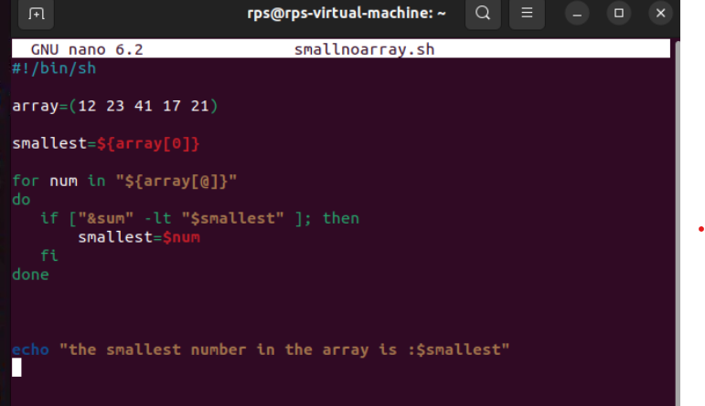

**Output:**

